Solution to Assignment03
- Two randomly selected grocery store patrons are each asked to take a blind taste test and to then state which of three diet colas (marked as A, B, or C) he or she prefers.
  - Draw a tree diagram depicting the sample space outcomes for the test results.
  - List the sample space outcomes that correspond to each of the following events:
    - Both patrons prefer diet cola A.
    - The two patrons prefer the same diet cola.
    - The two patrons prefer different diet colas.
    - Diet cola A is preferred by at least one of the two patrons.
    - Neither of the patrons prefers diet cola C.
  - Assuming that all sample space outcomes are equally likely, find the probability of each of the events given in part b
Solutions:
a. | 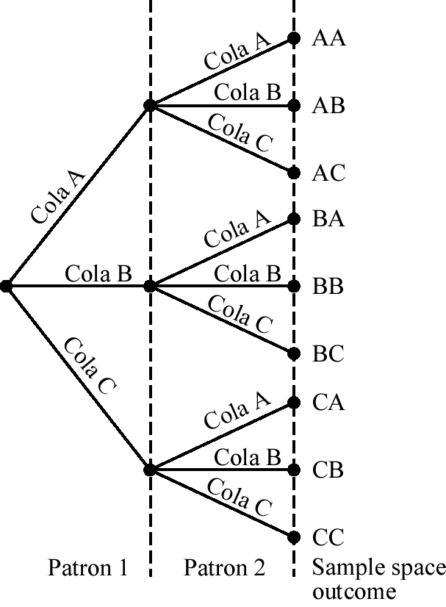

b. (1) AA
(2) AA, BB, CC
(3) AB, AC, BA, BC, CA, CB
(4) AA, AB, AC, BA, CA
(5) AA, AB, BA, BB
c. Each outcome has probability
(1)
(2)
(3)
(4)
(5)
- Recall from Exercise 4.11 (page 186) that of 10,000 students at a college, 2,500 have a Mastercard (M), 4,000 have a VISA (V), and 1,000 have both. Find
  - The proportion of Mastercard holders who have VISA cards. Interpret and write this proportion as a conditional probability.
  - The proportion of VISA cardholders who have Mastercards. Interpret and write this proportion as a conditional probability.
  - Are the events having a Mastercard and having a VISA independent? Justify your answer.
Solutions:
a.
b.
c. Yes, P(M | V) = P(M)

- John and Jane are married. The probability that John watches a certain television show is .4. The probability that Jane watches the show is .5. The probability that John watches the show, given that Jane does, is .7.
  - Find the probability that both John and Jane watch the show.
  - Find the probability that Jane watches the show, given that John does.
  - Do John and Jane watch the show independently of each other? Justify your answer.
Solutions:
a.
b. 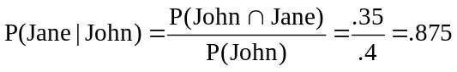
c. 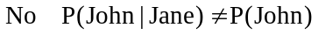

- Recall from Exercise 1 that two randomly selected customers are each asked to take a blind taste test and then to state which of three diet colas (marked as A, B, or C) he or she prefers. Suppose that cola A’s distributor claims that 80 percent of all people prefer cola A and that only 10 percent prefer each of colas B and C.
  - Assuming that the distributor’s claim is true and that the two taste test participants make independent cola preference decisions, find the probability of each sample space outcome.
  - Find the probability that neither taste test participant will prefer cola A.
  - If, when the taste test is carried out, neither participant prefers cola A, use the probability you computed in part b to decide whether the distributor’s claim seems valid. Explain.
Solutions:
a. P(AA) = (.8)(.8) = .64
P(AB) = (.8)(.1) = .08
P(AC) = (.8)(.1) = .08
P(BA) = (.1)(.8) = .08
P(BB) = (.1)(.1) = .01
P(BC) = (.1)(.1) = .01
P(CA) = (.1)(.8) = .08
P(CB) = (.1)(.1) = .01
P(CC) = (.1)(.1) = .01
b. P(BB) + P(BC) + P(CB) + P(CC) = 4(.01) = .04
c. Probably not valid since the probability in part b is small.

